OBESITY LEVEL PREDICTION

USING
MACHINE LEARNING

BASIC INFORMATION
Title of Project:
Obesity Level Prediction Using Machine Learning
Student Name:
Sachpreet Singh

ABSTRACT
Obesity has become one of the major global health concerns due to unhealthy eating habits, lack of physical activity, and lifestyle imbalance. Early prediction and analysis of obesity can help healthcare systems provide preventive recommendations and improve health awareness. This project focuses on predicting obesity levels using machine learning techniques based on eating habits and physical condition.
The dataset used in this project contains both numerical and categorical features such as age, height, weight, physical activity frequency, water intake, meal frequency, smoking habits, and transportation modes. Data preprocessing techniques including label encoding, feature scaling, and train-test splitting were applied to prepare the dataset for machine learning models.
Multiple machine learning algorithms were implemented for classification, regression, and clustering tasks. Classification models included Logistic Regression, Decision Tree, Random Forest, K-Nearest Neighbors (KNN), and Support Vector Machine (SVM). Regression models included Linear Regression, Decision Tree Regressor, Random Forest Regressor, KNN Regressor, and Support Vector Regressor (SVR). Clustering algorithms such as K-Means, Hierarchical Clustering, and DBSCAN were also applied to identify hidden patterns within the dataset.
The models were evaluated using metrics such as Accuracy, Precision, Recall, F1-Score, Mean Squared Error (MSE), R² Score, and Silhouette Score. Among all models, Random Forest achieved the best overall performance due to its ensemble learning capability and ability to handle complex relationships within the data.
This project demonstrates the effectiveness of machine learning techniques in healthcare-related prediction systems and highlights the importance of lifestyle-related factors in obesity prediction.

KEYWORDS
Machine Learning, Obesity Prediction, Classification, Regression, Clustering

1. INTRODUCTION
Obesity is a growing health issue affecting millions of people worldwide. It is associated with several serious diseases including diabetes, heart disease, high blood pressure, and other chronic health conditions. Obesity is primarily influenced by eating habits, physical activity, and lifestyle patterns.
Traditional methods of obesity analysis often rely on manual medical observation and statistical approaches. However, with the increasing availability of healthcare data, machine learning techniques provide a more efficient and intelligent approach for analyzing health conditions and predicting obesity levels.
Machine learning algorithms can analyze large datasets, identify hidden patterns, and make accurate predictions based on previous data. This project aims to use machine learning techniques to predict obesity levels based on eating habits and physical condition.
The project includes classification, regression, and clustering techniques to provide a complete analysis of the obesity dataset. Various machine learning models are compared to identify the best-performing algorithm.

Objectives of the Project
- Predict obesity levels using classification algorithms.
- Analyze obesity-related numerical relationships using regression models.
- Discover hidden patterns using clustering techniques.
- Compare machine learning models based on performance metrics.
- Identify important features affecting obesity prediction.

2. PROPOSED METHODOLOGY
The proposed methodology follows a systematic pipeline for obesity prediction using machine learning.

Methodology Workflow
Dataset Collection
↓
Data Preprocessing
↓
Exploratory Data Analysis (EDA)
↓
Feature Engineering & Scaling
↓
Train-Test Split
↓
Model Training
↓
Evaluation & Comparison
↓
Final Prediction

2(a). Dataset Description
The dataset used in this project is the “Estimation of Obesity Levels Based on Eating Habits and Physical Condition” dataset.
The dataset contains 2111 rows and 17 columns. It includes both categorical and numerical attributes related to physical condition, eating habits, and lifestyle.

Dataset Features
Feature | Type | Description
Age | Numerical | Age of individual
Height | Numerical | Height in meters
Weight | Numerical | Weight in kilograms
FCVC | Numerical | Frequency of vegetable consumption
NCP | Numerical | Number of main meals
CH2O | Numerical | Daily water intake
FAF | Numerical | Physical activity frequency
TUE | Numerical | Technology usage time
Gender | Categorical | Male/Female
family_history_with_overweight | Categorical | Family history of overweight
FAVC | Categorical | Frequent consumption of high-calorie food
SMOKE | Categorical | Smoking habit
SCC | Categorical | Calorie consumption monitoring
CAEC | Categorical | Food consumption between meals
MTRANS | Categorical | Transportation mode
CALC | Categorical | Alcohol consumption
NObeyesdad | Target Variable | Obesity Level

Output of First Five Rows
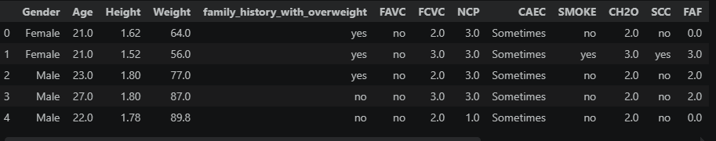

2(b). Data Preprocessing
Data preprocessing is an important step in machine learning because raw data often contains categorical values and varying feature scales.
The following preprocessing techniques were applied:

1. Label Encoding
Categorical features such as Gender, Smoking, and Transportation mode were converted into numerical values using Label Encoding.

2. Feature Scaling
StandardScaler was applied to normalize feature values and improve model performance.

3. Train-Test Split
The dataset was divided into training and testing datasets using an 80:20 ratio.

4. Target Selection
The target variable used for prediction is “NObeyesdad”, representing obesity level.

Preprocessing Code Screenshot
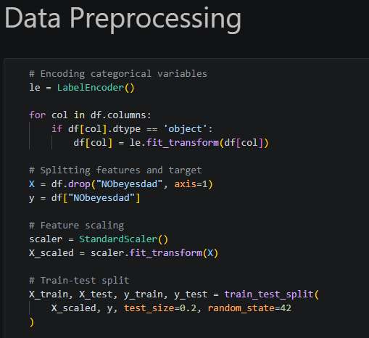

2(c). Exploratory Data Analysis (EDA)
Exploratory Data Analysis was performed to understand dataset distribution and identify patterns.

Obesity Distribution Graph
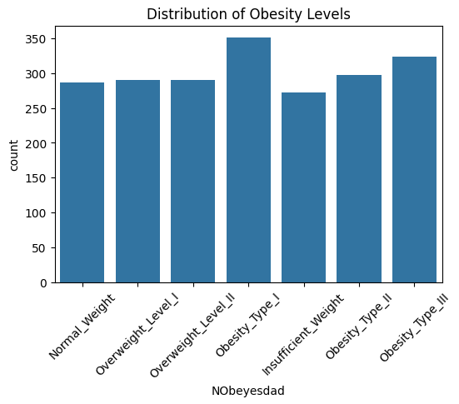

The graph shows the distribution of obesity levels within the dataset. It helps identify class balance and data spread.

Key Observations
- Some obesity categories contain more samples than others.
- Weight and physical activity appear strongly related to obesity levels.
- Lifestyle habits significantly influence obesity prediction.

2(d). Feature Engineering & Selection
Feature engineering was performed to improve model performance and understand the importance of various features.

Feature Importance Analysis
Random Forest was used to calculate feature importance scores.

Feature Importance Graph

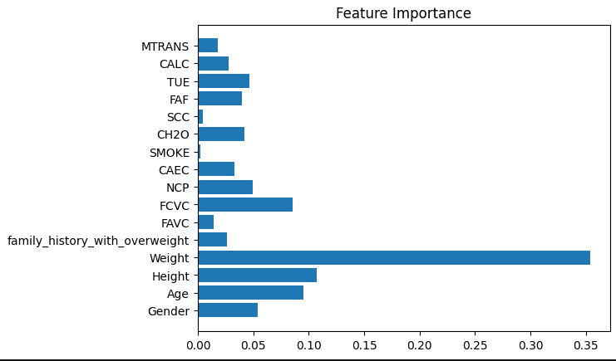

Important Features Identified
- Weight
- Physical Activity Frequency
- Eating Habits
- Water Intake
Weight showed the highest importance because obesity classification strongly depends on body mass indicators. Physical activity and eating habits also contributed significantly to prediction accuracy.

2(e). Classification Models
Five classification models were implemented and compared.

1. Logistic Regression
Logistic Regression is a linear classification algorithm used for predicting categorical outcomes.

Output

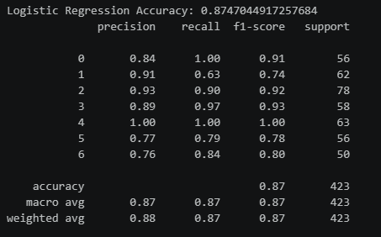

Observation
Logistic Regression showed moderate performance because it assumes linear decision boundaries.

2. Decision Tree Classifier
Decision Tree is a non-linear supervised learning algorithm that splits data into decision

nodes. Output
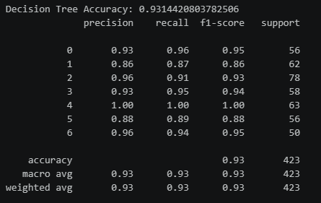

Observation
Decision Tree captured non-linear patterns effectively but showed slight overfitting tendencies.

3. Random Forest Classifier
Random Forest is an ensemble learning algorithm that combines multiple decision trees.

Output

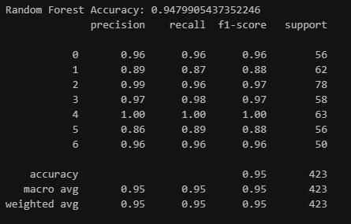

Observation
Random Forest achieved the highest accuracy due to ensemble learning, reduced overfitting, and improved generalization capability.

4. K-Nearest Neighbors (KNN)
KNN predicts class labels based on the nearest neighboring data points.

Output

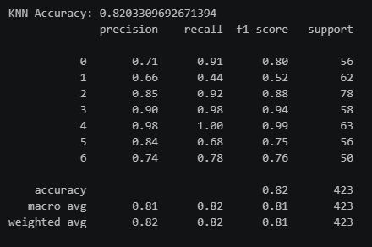

Observation
KNN performance depended heavily on feature scaling and distance calculations.

5. Support Vector Machine (SVM)
SVM separates classes using optimal hyperplanes.

Output

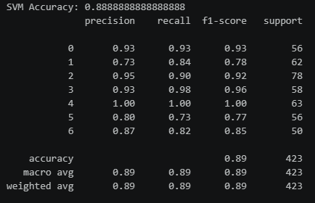

Observation
SVM performed well for high-dimensional data but required higher computational cost.

Classification Accuracy Comparison
Model | Accuracy
Logistic Regression | 0.8747044917257684
Decision Tree | 0.9314420803782506
Random Forest | 0.9479905437352246
KNN | 0.8203309692671394
SVM | 0.8888888888888888

Accuracy Comparison Graph

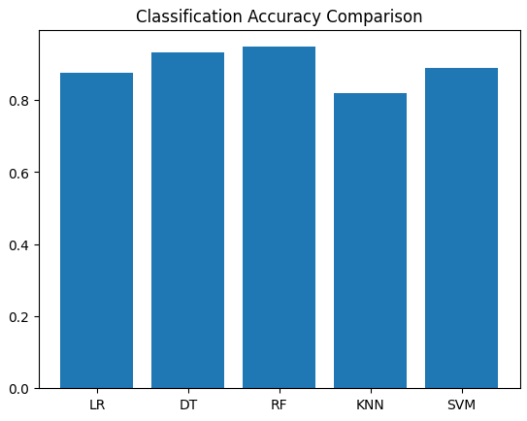

Final Observation
Random Forest outperformed other models because ensemble learning combines multiple decision trees, reducing variance and improving prediction capability.

2(f). Regression Models
Regression models were implemented by converting encoded obesity levels into numerical form.
Although obesity level is a categorical variable, regression models were applied for comparative analysis purposes.

Regression Models Used
- Linear Regression
- Decision Tree Regressor
- Random Forest Regressor
- KNN Regressor
- Support Vector Regressor

Regression Output Screenshots

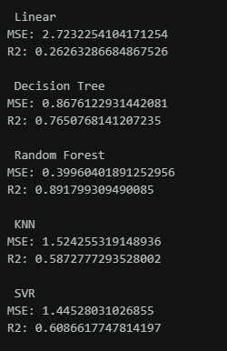

Regression Results Table
Model | MSE | R² Score
Linear Regression | 2.7232254104171254 | 0.26263286684867526
Decision Tree Regressor | 0.8676122931442081 | 0.7650768141207235
Random Forest Regressor | 0.39960401891252956 | 0.891799309490085
KNN Regressor | 1.524255319148936 | 0.5872777293528002
SVR | 1.44528031026855 | 0.6086617747814197

Observation
Random Forest Regressor achieved the best regression performance due to its ability to model complex non-linear relationships.

2(g). Clustering Models
Clustering algorithms were applied to discover hidden patterns within the dataset.

Clustering Algorithms Used
- K-Means Clustering
- Hierarchical Clustering
- DBSCAN

Clustering Outputs

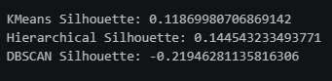

Clustering Results Table
Algorithm | Silhouette Score | Observation
K-Means | 0.11869980706869142 | Good cluster separation
Hierarchical | 0.144543233493771 | Moderate clustering
DBSCAN | -0.21946281135816306 | Density variation issue

Observation
K-Means produced the best clustering performance based on silhouette score.

3. RESULTS & DISCUSSION
The machine learning models were evaluated using different performance metrics including Accuracy, Precision, Recall, F1-Score, Mean Squared Error, R² Score, and Silhouette Score.
Among all classification models, Random Forest achieved the highest performance because it combines multiple decision trees to reduce overfitting and improve prediction capability.
SVM also showed strong performance due to its ability to handle complex decision boundaries. Logistic Regression performed comparatively lower because obesity data contains non-linear relationships.
For regression analysis, Random Forest Regressor produced the lowest error and highest R² score. Linear Regression showed weaker performance because obesity prediction is not purely linear.
Among clustering algorithms, K-Means produced the most meaningful clusters. DBSCAN struggled because of varying density distribution in the dataset.

Key Findings
- Weight is the most important feature affecting obesity prediction.
- Physical activity and eating habits strongly influence obesity levels.
- Ensemble learning models provide better prediction performance.
- Proper preprocessing significantly improves model accuracy.

Best Performing Model
Model | Performance
Random Forest Classifier | Best Overall Accuracy

Best Model Output
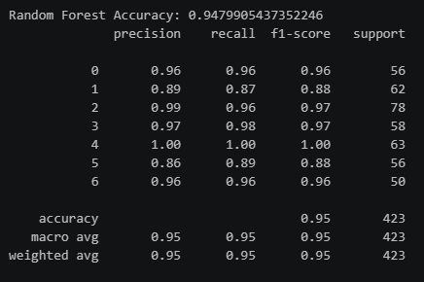

4. LIMITATIONS
The project contains several limitations:
- Regression analysis was applied on encoded categorical labels, which is not fully ideal for regression tasks.
- Dataset behavior may vary across different populations and regions.
- Lifestyle-based data may contain self-reporting bias.
- Hyperparameter tuning was limited due to project scope.

5. CONCLUSION & FUTURE WORK

Conclusion
This project successfully demonstrated the use of machine learning techniques for obesity prediction using eating habits and physical condition data.
Multiple classification, regression, and clustering algorithms were implemented and compared. Random Forest achieved the best overall performance due to its ensemble learning capability and ability to handle complex relationships within the dataset.
The project highlights the importance of healthy lifestyle habits and physical activity in obesity prevention and demonstrates the practical use of machine learning in healthcare analytics.

Future Work
Several improvements can be made in future work:
- Implement deep learning models for improved prediction accuracy.
- Use larger healthcare datasets for better generalization.
- Develop real-time obesity monitoring systems.
- Integrate wearable device data and IoT sensors.
- Build a web-based healthcare prediction application.
- Apply advanced hyperparameter optimization techniques.

REFERENCES
[1] World Health Organization. (2023). Obesity and overweight facts. Retrieved from https://www.who.int
[2] Breiman, L. (2001). Random Forests. Machine Learning, 45(1), 5–32.
[3] Cortes, C., & Vapnik, V. (1995). Support-vector networks. Machine Learning, 20(3), 273–297.
[4] Pedregosa, F., Varoquaux, G., Gramfort, A., et al. (2011). Scikit-learn: Machine Learning in Python. Journal of Machine Learning Research, 12, 2825–2830.

APPENDIX

Google Drive Contents
The Google Drive folder contains:
- Final Report
- Dataset (.csv)
- Source Code Files
- References

Google Drive Links

Code: https://drive.google.com/file/d/195IsDvP2fLWPrHE2hfWsUSvZ1QxfHXMH/view?usp=drive_link
Dataset: https://drive.google.com/file/d/1utAGox4tPrcCAipmR8eOqkdMPyU2umDN/view?usp=drive_link
Report:
https://docs.google.com/document/d/1Y3x6CsOMj-zgz3JOSxNomq5bJHIPTSFE/edit?usp=drive_link&ouid=101596215752426139288&rtpof=true&sd=true

